DESN6002 Foundations of Creative Code

Rationale and Research Report

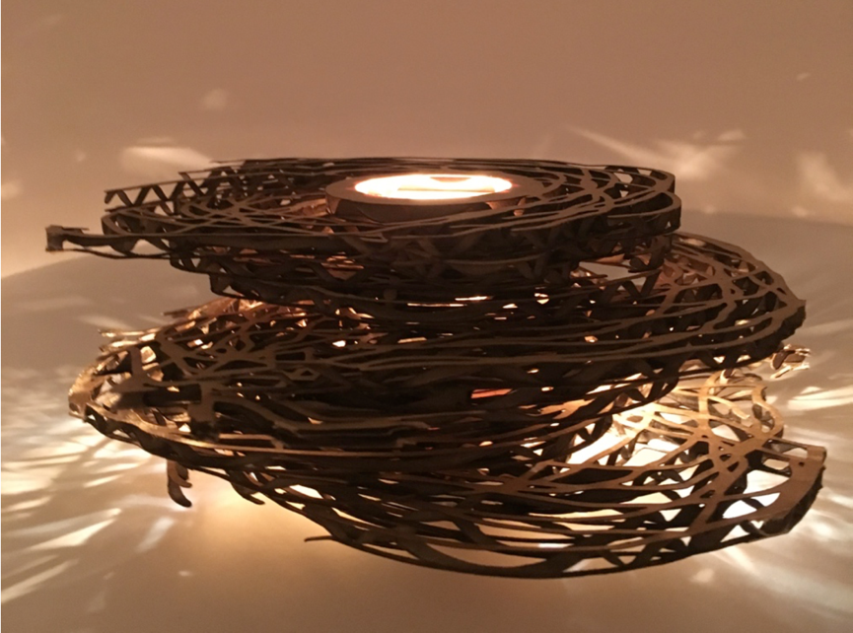

Jieming Hu

u5841919

This report provides a view of the research that was done to carry out our swarm code project for DESN6002 foundations of creative code. Research into characters of swarm code as well as how practitioners follow the rules of design to create the object and the rationale for the objects’ context are also provided. The author explores the cultural context of their project and ends the report with a review of the creation process of their artwork: layering light.

## Our creative code works

I used P5.js.to code our swarm project. “p5.js a JS client-side library for creating graphic and interactive experiences, based on the core principles of Processing.”[1] The swarm code work that I created is a composition of many single “agents” operating following simple rules and together, these agents produce a holistic effect. Some of the simple rules are “separation or avoidance”, “coherence” and “alignment”. “avoidance” means each agent move without getting into its nearest neighbours and “coherence” means all the agents move towards the centre of their nearby neighbours and “alignment” means that agents move in roughly the same direction as its neighbours. Having specified rules for each single element, it should be noted that there are no rules to determine the behaviour of the system as a whole. [2]

I think the swarm system offers a good artistic pattern for our project so that I code with the above mentioning rules in mind. The design was to scope the agents’ roundabouts within a circle while keeping the agents clear from a circle in the center. The “avoidance” rule was applied when I coded the swarms in a way that agents stay close together without getting into each other when they move around. The “coherent” rule was also followed as I kept the agents close together so that they form one integrity without becoming an opaque plaque.

In practice, me and my team member use the swam code to create frames and captured the changing patterns of the frame by freeze every 300 frames as the agents all revolve around a pole.

## Practitioners

The practitioners of this agent based simulation project are me, jieming Hu, Patrick Rose and Andy Mullens. I am a master of computing student while the rest of my team are from liberal art backgrounds. As a software engineering student, I was familiar with other coding languages and javascript was only acquired through this course. But as everyone in my team who get outside our comfort zone, I manage to code the bulk of the swarm project and I found the thinking and designing process of writing the functions and coding somewhat similar to using other similar programming languages. An example of how my knowledge has helped the team was with an understanding of parameters of code, the circular bounding box for restricting the movements of agents were designed by me.

Patrick designed the frames that were to be laser cut to final frames and Andy’s proposal for the artwork to be displayed as a maquette and assisting with the concept development and documentation all made the swarm project a highly articulated design.

## Creative code works contexts

The context that the swarm project code later materialized into was a fabricated artwork made by laser cutting corrugated cardboards that followed the design of frames of my code. To fabricate the design is a critical process and decision because it is only through fabricated prototype that the 2D design of swarm codes could become 3D. Setting up against light, the effects of multi-dimensional masqutte achieve a multi-layered visual effects unthinkable by looking from the swarm code effects on computer screen.

The choice of laser cutting as a way of fabrication is worth mentioning as we think laser cutting would give us the precision that was need for cardboard printing. Literature says that “laser cutting enables the finest level of details on majority of materials. [3]

## Research in to specific application of creative code in our chosen cultural context

The culture context we chose for our installation piece of work as a contemporary sculpture are in art galleries.

The title of our installation piece is “layering light”. As the name suggests, the art work will deliver a unique effect of lighting projected through the layering of laser patterned corrugated cardboards. Thus, the display of the piece would be most fittingly arranged in an art gallery where open space and controlled lighting could be provided to maximize the artistic effects of our design.

As the saying goes, there are a thousand ways to interpret an artwork, the cultural connotation people attach to this piece of work could be very different. My team mate see the layering light conveys a sense of duality of object and space and comparison between negativity and positivity. I see the work conveying a sense of “complexity within simplicity”. As complex shadow is framed through the random openings of layering cardboards, I marvel at how simple patterns of openings, layered together, would create delicate and intricate shadow.

Since different people would read differently into the object, it is again best fitted to be placed in an art gallery where people are allowed the space and time for pause and reflections.

Our team’s inspiration for this design was as a result of being informed by the following artworks entries we found on the internet:

• Swirling clay on kick wheel by Mikhail SADOVNIKOV

<https://www.youtube.com/watch?v=jWAa7EigJRs&t=5s>

• "The Splendor of Color Kaleidoscope"

<https://www.youtube.com/watch?v=q2fIWB8o-bs>

• Nick Dong Cosmic Dance – Gravity, 2015 (breathing surface, floating cube, light, mirrors)

<https://www.studiodong.com/cosmic-dance>

<https://vimeo.com/136173495>

• Box installation

<https://www.youtube.com/watch?v=lX6JcybgDFo>

• Effects of Light through Laser cutting

<http://www.journal-du-design.fr/design/les-baleines-en-bois-lumineuses-et-sculpturales-deduard-golikov-77318/>

• Troika Cloud, London, Heathrow airport

<https://www.youtube.com/watch?v=1lPy7cwhr_w>

• Nervous System generative lamp

<https://n-e-r-v-o-u-s.com/shop/search_tags.php?search=lighting>

• James Turrell – all his work, or more specifically Ganzfeld

<http://jamesturrell.com/work/type/ganzfeld/>

<https://nga.gov.au/JamesTurrell/>

• Anthony McCall You and I Horizontal, 2005 (laser shapes through smoke machines in dark room)

<https://www.youtube.com/watch?v=HgzcbQlwT6w>

<http://www.anthonymccall.com/exhibitions.html>

<https://www.mca.com.au/collection/exhibition/706-light-show/>

## The Creative Process

As our team have documented the creative process in our last assignment, I would highlight on things to explain the story behind “layering light”.

One thing is I didn’t think of fabricating the swarm codes in the first place as I thought coding it and playing it on screen would suffice. It was after my team mates proposed that we should fabricate the design that I followed their suggestion which turned out to be making a real difference. As I realized, the fabrication of the swarm codes put the two-dimensional work into a three-dimensional installation that deliver a completely different visual effects as it would have appeared on screen.

Another thing was that our idea changed during the fabrication process in using the opposite part of the cut cardboard as we originally intended. What we intended to use was a donut shaped cardboard. However, we thought it would be a more dynamic and visually striking piece if we took out the inner form, “the movement of the agents themselves” as put by my team mate. This had in fact created a much better visual effect and brought us an instant sense of gratification.

## Reference

[1]"p5.js | home", *P5js.org*, 2017. [Online]. Available: https://p5js.org/. [Accessed: 29- May- 2017].

[2]"Boids (Flocks, Herds, and Schools: a Distributed BehavioralModel)", *Red3d.com*, 2017. [Online]. Available: http://www.red3d.com/cwr/boids/. [Accessed: 29- May- 2017].

[3] Instructables.com, 2017. [Online]. Available: http://www.instructables.com/id/Laser-Cutting-for-Art-and-Industrial-Creativity/. [Accessed: 29- May- 2017].